LAPORAN TUGAS PEMROGRAMAN WEB
TUGAS KEDUA—Praktikum Modul Kedua: PHP



Nama : Theo Jesen Naftali Sirait
NRP : 3125600106
Dosen Pengajar : Prof. M. Udin Harun Al Rasyid S. Kom, Ph. D

PROGRAM STUDI S. Tr. TEKNIK INFORMATIKA
POLITEKNIK ELEKTRONIKA NEGERI SURABAYA (PENS)
TAHUN 2026
BAB I
PERCOBAAN
  - Percobaan Pertama—Form Handling & Validation
    - Source Code:
<?php
$namaErr = $emailErr = $linkErr = "";
$nama = $email = $link = "";

if ($_SERVER["REQUEST_METHOD"] == "POST") {

if (empty($_POST["nama"])) {
$namaErr = "Nama tidak boleh kosong";
} else {
$nama = htmlspecialchars($_POST["nama"]);
}

if (!filter_var($_POST["email"], FILTER_VALIDATE_EMAIL)) {
$emailErr = "Email tidak valid";
} else {
$email = $_POST["email"];
}

if (!preg_match("/\b(?:(?:https?|ftp):\/\/|www\.)[-a-z0-9+&@#\/%?=~_|!:,.;]*[-a-z0-9+&@#\/%=~_|]/i", $_POST["link"])) {
$linkErr = "Link tidak valid";
} else {
$link = $_POST["link"];
}
}
?>

<form method="post" action="<?php echo $_SERVER['PHP_SELF'];?>">
Nama: <input type="text" name="nama"> <span>* <?php echo $namaErr;?></span><br>
Email: <input type="text" name="email"> <span>* <?php echo $emailErr;?></span><br>
Link Portfolio: <input type="text" name="link"> <span><?php echo $linkErr;?></span><br>
<input type="submit" value="Kirim">
</form>

    - Output:
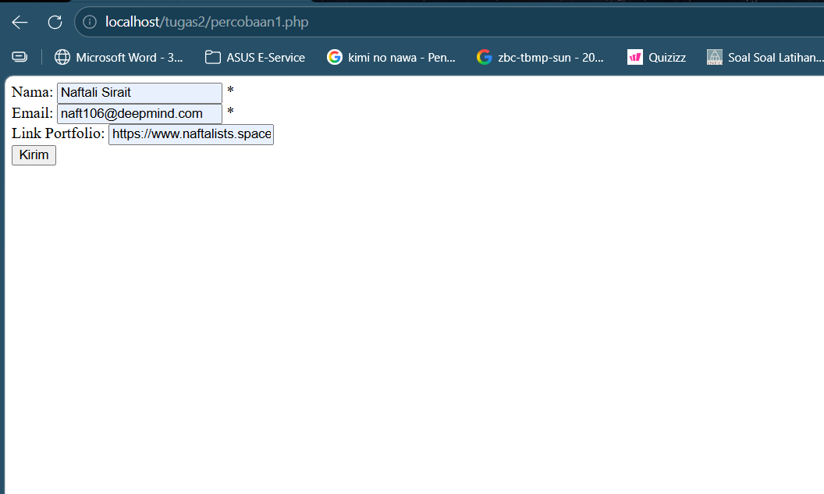

    - Penjelasan:
Percobaan ini menunjukkan bagaimana server memproses data dari form dan memastikan input tidak asal masuk. Script mengecek apakah request datang lewat metode POST, lalu memvalidasi setiap field: nama dicek kosong atau tidak, email diverifikasi dengan filter_var() agar sesuai format standar, dan URL diuji pakai regex untuk memastikan bentuknya benar. Fungsi htmlspecialchars() dipakai untuk menghindari XSS (Cross-Site Scripting), yaitu serangan di mana user menyisipkan script berbahaya ke dalam input.

  - Percobaan Kedua—Date, Time, and Include
    - Source Code:
INDEX:
<?php
echo "<h1>Selamat Datang di Portal Mahasiswa</h1>";
include 'percobaan2_footer.php';
?>

FOOTER:
<?php
echo "<hr>";
echo "<p>&copy; " . date("Y") . " Sistem Akademik Kampus</p>";
?>

    - Output:
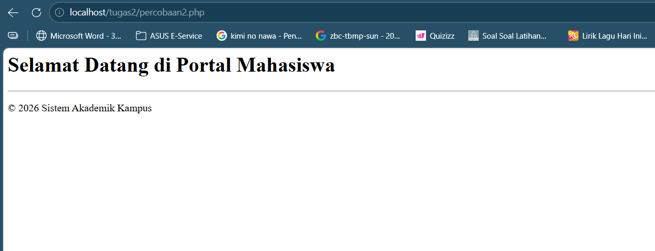

    - Penjelasan:
Fungsi date("Y") mengambil tahun saat ini dari server, jadi konten selalu update tanpa perlu diubah manual. Sementara include memungkinkan untuk memecah kode jadi beberapa file agar lebih rapi dan reusable—misalnya footer yang sama dipakai di banyak halaman. Bedanya dengan require, include tidak menghentikan program kalau file tidak ditemukan.

  - Percobaan Ketiga—File Handling
    - Source Code:
<?php
$fileLog = fopen("aktivitas.txt", "a") or die("File gagal dibuka!");
$isi = "Akses pada jam: " . date("H:i:s") . "\n";
fwrite($fileLog, $isi);
fclose($fileLog);
$baca = fopen("aktivitas.txt", "r");
echo fread($baca, filesize("aktivitas.txt"));
fclose($baca);
?>

    - Output:
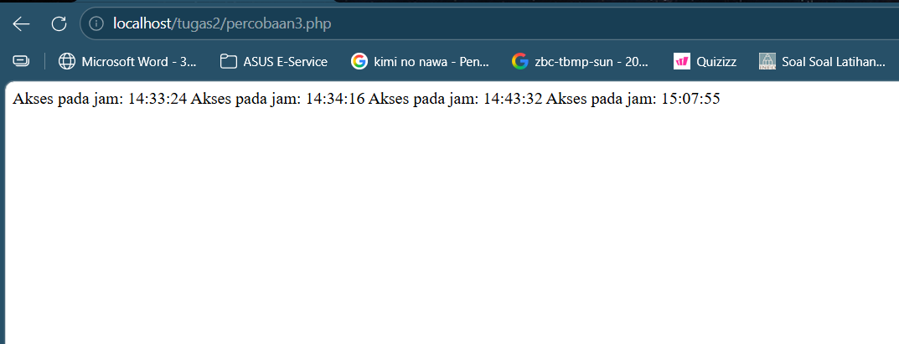

    - Penjelasan:
Percobaan ini memperlihatkan bagaimana PHP berinteraksi langsung dengan file di server. fopen() membuka file dengan mode tertentu (append untuk menambah isi, read untuk membaca), lalu fwrite() mencatat aktivitas (semacam log sederhana), dan fread() menampilkan isi file tersebut. Ini konsep dasar logging—sesuatu yang kelihatannya sepele tapi krusial di sistem nyata untuk debugging dan audit.

  - Percobaan Keempat—Sessions and Cookies
    - Source Code:
<?php
session_start();

setcookie("tema_user", "light_mode", time() + 3600, "/");

$_SESSION["user_login"] = "Admin_Portal";

echo "User aktif: " . $_SESSION["user_login"] . "<br>";

if (isset($_COOKIE["tema_user"])) {
echo "Tema saat ini: " . $_COOKIE["tema_user"];
}
?>
    - Output:
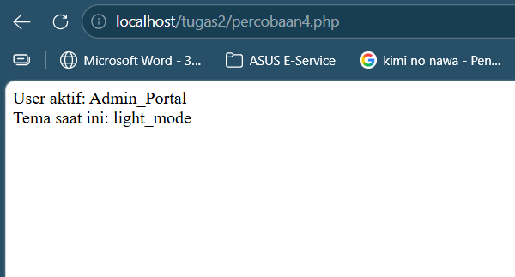

    - Penjelasan:
setcookie() menyimpan preferensi user di browser (misalnya tema), sedangkan $_SESSION menyimpan data di server selama sesi aktif (misalnya status login). session_start() wajib dipanggil dulu karena tanpa itu PHP tidak tahu sesi mana yang sedang digunakan. Konsep ini inti dari autentikasi—tanpa session, setiap request itu “amnesia”, tidak tahu siapa usernya.

  - Percobaan Kelima—PHP JSON and Filters
    - Source Code:
<?php
$mahasiswa = [
"nama" => "Siti Rahma",
"nim" => "7891011",
"jurusan" => "Teknik Informatika"
];

$json = json_encode($mahasiswa);
echo "Response API: " . $json . "<br>";

$input = "<script>alert('hack')</script>";
$bersih = htmlspecialchars($input, ENT_QUOTES, 'UTF-8');

echo "Hasil sanitasi: " . $bersih;
?>
    - Output:
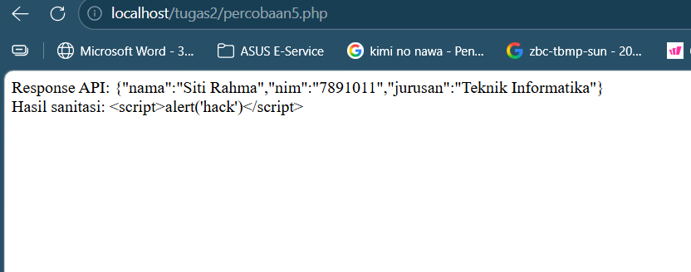

    - Penjelasan:
Percobaan ini mengarah ke dunia API dan keamanan input. json_encode() mengubah array PHP menjadi format JSON, yang merupakan standar komunikasi antar sistem (frontend-backend, atau antar server). Sementara filter_var() dengan FILTER_SANITIZE_STRING digunakan untuk membersihkan input dari tag HTML berbahaya.

BAB II
TUGAS PRAKTIKUM
  - Aplikasi Guest Book Sederhana
    - Source Code:
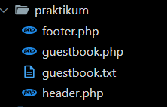

header.php:
<!DOCTYPE html>
<html lang="id">
<head>
<meta charset="UTF-8">
<meta name="viewport" content="width=device-width, initial-scale=1.0">
<title>GuestBook</title>
<link rel="preconnect" href="https://fonts.googleapis.com">
<link href="https://fonts.googleapis.com/css2?family=Playfair+Display:ital,wght@0,400;0,600;0,700;1,400&family=Cormorant+Garamond:wght@300;400;500&family=Crimson+Text:ital,wght@0,400;0,600;1,400&display=swap" rel="stylesheet">
<style>
:root {
--navy-deep: #060e1f;
--navy: #0d1f3c;
--navy-mid: #142850;
--navy-light: #1e3a6e;
--gold-bright: #f0c040;
--gold: #c9922a;
--gold-muted: #9e7420;
--gold-pale: #f5e2a3;
--white: #f8f5ee;
--white-dim: rgba(248,245,238,0.75);
--white-faint: rgba(248,245,238,0.12);
--border-gold: rgba(201,146,42,0.35);
}
*, *::before, *::after { box-sizing: border-box; margin: 0; padding: 0; }
html { scroll-behavior: smooth; }
body {
background-color: var(--navy-deep);
background-image:
radial-gradient(ellipse 80% 50% at 50% -10%, rgba(201,146,42,0.07) 0%, transparent 70%),
repeating-linear-gradient(0deg, transparent, transparent 79px, rgba(201,146,42,0.025) 79px, rgba(201,146,42,0.025) 80px),
repeating-linear-gradient(90deg, transparent, transparent 79px, rgba(201,146,42,0.025) 79px, rgba(201,146,42,0.025) 80px);
color: var(--white);
font-family: 'Crimson Text', Georgia, serif;
font-size: 17px;
line-height: 1.65;
min-height: 100vh;
}
/* Header */
.site-header {
position: relative;
text-align: center;
padding: 56px 20px 48px;
overflow: hidden;
}
.site-header::before {
content: '';
position: absolute;
inset: 0;
background: linear-gradient(180deg, rgba(201,146,42,0.06) 0%, transparent 100%);
pointer-events: none;
}
.header-ornament {
display: flex;
align-items: center;
justify-content: center;
gap: 14px;
margin-bottom: 20px;
opacity: 0;
animation: fadeDown 0.8s ease forwards 0.1s;
}
.orn-line {
flex: 1; max-width: 120px; height: 1px;
background: linear-gradient(90deg, transparent, var(--gold), transparent);
}
.orn-dia { width: 10px; height: 10px; background: var(--gold); transform: rotate(45deg); flex-shrink: 0; }
.orn-dia-s { width: 5px; height: 5px; background: var(--gold-muted); transform: rotate(45deg); flex-shrink: 0; }
.site-header h1 {
font-family: 'Playfair Display', serif;
font-size: clamp(2.2rem, 5vw, 3.6rem);
font-weight: 700;
letter-spacing: 0.04em;
color: var(--white);
line-height: 1.1;
opacity: 0;
animation: fadeDown 0.9s ease forwards 0.25s;
}
.site-header h1 em { color: var(--gold-bright); font-style: italic; }
.site-header .subtitle {
font-family: 'Cormorant Garamond', serif;
font-size: 0.9rem;
font-weight: 300;
letter-spacing: 0.22em;
text-transform: uppercase;
color: var(--gold-muted);
margin-top: 10px;
opacity: 0;
animation: fadeDown 0.9s ease forwards 0.4s;
}
.header-orn-bot { margin-top: 24px; opacity: 0; animation: fadeDown 0.8s ease forwards 0.5s; }

/* Animations */
@keyframes fadeDown { from { opacity:0; transform:translateY(-16px); } to { opacity:1; transform:translateY(0); } }
@keyframes fadeUp { from { opacity:0; transform:translateY(24px); } to { opacity:1; transform:translateY(0); } }
@keyframes fadeIn { from { opacity:0; } to { opacity:1; } }
@keyframes shimmer { 0%{background-position:-200% center;} 100%{background-position:200% center;} }
/* Layout */
.container { max-width: 820px; margin: 0 auto; padding: 0 20px 60px; }
/* Welcome banner */
.welcome-banner {
background: linear-gradient(135deg, var(--navy-light) 0%, var(--navy-mid) 100%);
border: 1px solid var(--gold);
border-radius: 4px;
padding: 16px 24px;
margin-bottom: 32px;
display: flex;
align-items: center;
gap: 14px;
position: relative;
overflow: hidden;
animation: fadeUp 0.6s ease forwards;
}
.welcome-banner::before {
content: '';
position: absolute;
top: 0; left: 0; right: 0; height: 2px;
background: linear-gradient(90deg, transparent, var(--gold-bright), transparent);
}
.welcome-banner .wb-icon { font-size: 1.5rem; flex-shrink: 0; }
.welcome-banner p { font-family: 'Playfair Display', serif; font-size: 1.05rem; color: var(--gold-pale); }
.welcome-banner p strong { color: var(--gold-bright); }

/* Card */
.card {
background: linear-gradient(160deg, rgba(20,40,80,0.9) 0%, rgba(13,31,60,0.95) 100%);
border: 1px solid var(--border-gold);
border-radius: 6px;
padding: 40px 44px;
position: relative;
overflow: hidden;
opacity: 0;
animation: fadeUp 0.7s ease forwards;
}
.card::before {
content: '';
position: absolute;
top: 0; left: 0; right: 0; height: 2px;
background: linear-gradient(90deg, transparent 0%, var(--gold) 40%, var(--gold-bright) 60%, transparent 100%);
}
.card-title {
font-family: 'Playfair Display', serif;
font-size: 1.4rem;
font-weight: 600;
color: var(--white);
margin-bottom: 28px;
display: flex;
align-items: center;
gap: 12px;
}
.card-title::after {
content: '';
flex: 1; height: 1px;
background: linear-gradient(90deg, var(--border-gold), transparent);
}
/* Form */
.form-group { margin-bottom: 22px; position: relative; }
.form-group label {
display: block;
font-family: 'Cormorant Garamond', serif;
font-size: 0.8rem;
font-weight: 500;
letter-spacing: 0.18em;
text-transform: uppercase;
color: var(--gold-muted);
margin-bottom: 8px;
transition: color 0.2s;
}
.form-group:focus-within label { color: var(--gold-bright); }
.form-group input,
.form-group textarea {
width: 100%;
background: rgba(6,14,31,0.7);
border: 1px solid rgba(201,146,42,0.25);
border-radius: 4px;
padding: 13px 16px;
color: var(--white);
font-family: 'Crimson Text', serif;
font-size: 1rem;
outline: none;
transition: border-color 0.25s, background 0.25s, box-shadow 0.25s;
-webkit-appearance: none;
}
.form-group input::placeholder,
.form-group textarea::placeholder { color: rgba(248,245,238,0.22); font-style: italic; }
.form-group input:focus,
.form-group textarea:focus {
border-color: var(--gold);
background: rgba(6,14,31,0.9);
box-shadow: 0 0 0 3px rgba(201,146,42,0.1), inset 0 1px 3px rgba(0,0,0,0.3);
}
.form-group input.err, .form-group textarea.err {
border-color: #d95555;
box-shadow: 0 0 0 3px rgba(217,85,85,0.1);
}
.form-group textarea { resize: vertical; min-height: 110px; }
.field-error {
font-family: 'Cormorant Garamond', serif;
font-size: 0.88rem;
color: #f07070;
margin-top: 6px;
display: flex;
align-items: center;
gap: 6px;
animation: fadeUp 0.3s ease;
}
.field-error::before { content: '⚠'; font-size: 0.78rem; }
/* Button */
.btn-submit {
width: 100%;
margin-top: 10px;
padding: 15px 32px;
background: linear-gradient(135deg, var(--gold-muted) 0%, var(--gold) 50%, var(--gold-muted) 100%);
background-size: 200% auto;
color: var(--navy-deep);
border: none;
border-radius: 4px;
font-family: 'Cormorant Garamond', serif;
font-size: 1rem;
font-weight: 500;
letter-spacing: 0.2em;
text-transform: uppercase;
cursor: pointer;
transition: background-position 0.4s ease, transform 0.15s, box-shadow 0.3s;
position: relative;
overflow: hidden;
}
.btn-submit:hover {
background-position: right center;
transform: translateY(-1px);
box-shadow: 0 6px 24px rgba(201,146,42,0.3);
}
.btn-submit:active { transform: translateY(0); }
/* Alert */
.alert-success {
background: linear-gradient(135deg, rgba(20,60,40,0.8), rgba(10,40,25,0.9));
border: 1px solid rgba(80,200,120,0.4);
border-radius: 4px;
padding: 14px 20px;
margin-bottom: 24px;
color: #90e0a8;
font-family: 'Crimson Text', serif;
font-size: 1rem;
display: flex;
align-items: center;
gap: 10px;
animation: fadeUp 0.5s ease;
}
.alert-success::before { content: '✓'; font-weight: bold; }
/* Divider */
.section-divider {
display: flex;
align-items: center;
gap: 18px;
margin: 44px 0 36px;
opacity: 0;
animation: fadeIn 0.8s ease forwards 0.6s;
}
.section-divider .deco-line { flex:1; height:1px; background:linear-gradient(90deg,transparent,var(--border-gold),transparent); }
.section-divider .deco-label { font-family:'Cormorant Garamond',serif; font-size:0.75rem; letter-spacing:0.28em; text-transform:uppercase; color:var(--gold-muted); white-space:nowrap; }
/* Guest list */
.guest-count { font-family:'Cormorant Garamond',serif; font-size:0.8rem; letter-spacing:0.15em; text-transform:uppercase; color:var(--gold-muted); margin-bottom:20px; }
.guest-count span { color:var(--gold-bright); font-weight:500; }
.guest-list { display:flex; flex-direction:column; gap:16px; }
.guest-card {
background: rgba(14,28,58,0.7);
border: 1px solid rgba(201,146,42,0.13);
border-left: 3px solid var(--gold-muted);
border-radius: 4px;
padding: 20px 24px;
position: relative;
transition: border-left-color 0.3s, background 0.3s, transform 0.22s;
opacity: 0;
animation: fadeUp 0.5s ease forwards;
}
.guest-card:hover { background:rgba(20,40,80,0.8); border-left-color:var(--gold-bright); transform:translateX(4px); }
.gc-header { display:flex; align-items:baseline; justify-content:space-between; gap:12px; margin-bottom:8px; flex-wrap:wrap; }
.gc-name { font-family:'Playfair Display',serif; font-size:1.05rem; font-weight:600; color:var(--gold-pale); }
.gc-meta { font-family:'Cormorant Garamond',serif; font-size:0.82rem; color:rgba(248,245,238,0.38); letter-spacing:0.05em; }
.gc-msg { font-family:'Crimson Text',serif; font-size:0.98rem; color:var(--white-dim); line-height:1.55; font-style:italic; }
.gc-num { position:absolute; top:16px; right:18px; font-family:'Cormorant Garamond',serif; font-size:1.9rem; color:rgba(201,146,42,0.08); font-weight:300; line-height:1; pointer-events:none; }
.no-guests { text-align:center; padding:48px 20px; font-family:'Cormorant Garamond',serif; font-size:1rem; color:rgba(248,245,238,0.28); letter-spacing:0.06em; font-style:italic; }

/* JSON output box */
.json-box {
background: rgba(6,14,31,0.85);
border: 1px solid rgba(201,146,42,0.2);
border-radius: 4px;
padding: 16px 20px;
font-family: 'Courier New', monospace;
font-size: 0.82rem;
color: var(--gold-pale);
margin-top: 16px;
overflow-x: auto;
white-space: pre-wrap;
word-break: break-all;
line-height: 1.6;
}
.json-toggle {
display: inline-block;
margin-top: 10px;
font-family: 'Cormorant Garamond', serif;
font-size: 0.82rem;
letter-spacing: 0.1em;
color: var(--gold-muted);
text-transform: uppercase;
cursor: pointer;
border: none;
background: none;
padding: 6px 0;
transition: color 0.2s;
}
.json-toggle:hover { color: var(--gold-bright); }
.json-toggle::before { content: '{ } '; }
@media(max-width:600px){
.card{padding:26px 20px;}
.site-header h1{font-size:2rem;}
}
</style>
</head>
<body>
<header class="site-header">
<div class="header-ornament">
<span class="orn-line"></span>
<span class="orn-dia-s"></span>
<span class="orn-dia"></span>
<span class="orn-dia-s"></span>
<span class="orn-line"></span>
</div>
<h1>Guest <em>Book</em></h1>
<p class="subtitle"> &nbsp;&middot;&nbsp; pernikahan | naftali x Go Younjung</p>
<div class="header-orn-bot">
<div class="header-ornament" style="margin-bottom:0;">
<span class="orn-line"></span>
<span class="orn-dia-s"></span>
<span class="orn-dia"></span>
<span class="orn-dia-s"></span>
<span class="orn-line"></span>
</div>
</div>
</header>
<div class="container">

guestbook.php:
<?php
session_start();

$nameErr = $emailErr = $pesanErr = "";
$name = $email = $pesan = "";
$successMsg = "";
$newEntry = null;

if ($_SERVER["REQUEST_METHOD"] == "POST") {

// Validasi Nama — Percobaan 1: empty check + htmlspecialchars
if (empty(trim($_POST["name"]))) {
$nameErr = "Nama wajib diisi";
} else {
$name = htmlspecialchars(trim($_POST["name"]));
}

// Validasi Email — Percobaan 1: filter_var FILTER_VALIDATE_EMAIL
$rawEmail = trim($_POST["email"]);
if (empty($rawEmail)) {
$emailErr = "Email wajib diisi";
} elseif (!filter_var($rawEmail, FILTER_VALIDATE_EMAIL)) {
$emailErr = "Format email tidak valid";
} else {
$email = htmlspecialchars($rawEmail);
}
// Validasi Pesan
if (empty(trim($_POST["pesan"]))) {
$pesanErr = "Pesan tidak boleh kosong";
} else {
$pesan = htmlspecialchars(trim($_POST["pesan"]));
}
// Simpan ke file jika semua valid
if (empty($nameErr) && empty($emailErr) && empty($pesanErr)) {
// Percobaan 5: json_encode — setiap entri disimpan sebagai satu baris JSON
$newEntry = [
"nama" => $name,
"email" => $email,
"pesan" => $pesan,
"waktu" => date("d M Y, H:i")
];
$jsonLine = json_encode($newEntry, JSON_UNESCAPED_UNICODE) . "\n";
// Percobaan 3: fopen "a" (append) + fwrite + fclose
$file = fopen("guestbook.txt", "a") or die("Gagal membuka file!");
fwrite($file, $jsonLine);
fclose($file);
// Session — instruksi no. 4
$_SESSION["last_visitor"] = $name;
$successMsg = "Terima kasih, <strong>" . $name . "</strong>! Pesan Anda telah dicatat.";
$name = $email = $pesan = "";
}
}
// Baca semua entri — Percobaan 3: fopen "r" + fread + fclose
$guests = [];
if (file_exists("guestbook.txt") && filesize("guestbook.txt") > 0) {
$readFile = fopen("guestbook.txt", "r");
$raw = fread($readFile, filesize("guestbook.txt"));
fclose($readFile);
$lines = array_filter(explode("\n", trim($raw)));
foreach ($lines as $line) {
$decoded = json_decode(trim($line), true);
if ($decoded) $guests[] = $decoded;
}
$guests = array_reverse($guests);
}

// Include header — Percobaan 2
include 'header.php';
?>
<?php if (isset($_SESSION["last_visitor"])): ?>
<div class="welcome-banner">
<span class="wb-icon">&#10022;</span>
<p>Selamat Datang Kembali, <strong><?php echo htmlspecialchars($_SESSION["last_visitor"]); ?></strong> &mdash; senang melihat Anda kembali!</p>
</div>
<?php endif; ?>
<div class="card" style="animation-delay:0.15s;">
<h2 class="card-title">Tulis Pesan</h2>
<?php if ($successMsg): ?>
<div class="alert-success"><?php echo $successMsg; ?></div>
<?php endif; ?>
<form method="post" action="<?php echo htmlspecialchars($_SERVER['PHP_SELF']); ?>" novalidate>
<div class="form-group">
<label for="name">Nama Lengkap</label>
<input type="text" id="name" name="name"
placeholder="Masukkan nama Anda..."
value="<?php echo htmlspecialchars($name); ?>"
<?php if ($nameErr) echo 'class="err"'; ?>>
<?php if ($nameErr): ?><span class="field-error"><?php echo $nameErr; ?></span><?php endif; ?>
</div>
<div class="form-group">
<label for="email">Alamat Email</label>
<input type="text" id="email" name="email"
placeholder="nama@contoh.com"
value="<?php echo htmlspecialchars($email); ?>"
<?php if ($emailErr) echo 'class="err"'; ?>>
<?php if ($emailErr): ?><span class="field-error"><?php echo $emailErr; ?></span><?php endif; ?>
</div>
<div class="form-group">
<label for="pesan">Pesan</label>
<textarea id="pesan" name="pesan"
placeholder="Tuliskan pesan atau komentar Anda di sini..."
<?php if ($pesanErr) echo 'class="err"'; ?>><?php echo htmlspecialchars($pesan); ?></textarea>
<?php if ($pesanErr): ?><span class="field-error"><?php echo $pesanErr; ?></span><?php endif; ?>
</div>

<button type="submit" class="btn-submit">Kirim Pesan</button>
</form>
</div>
<?php if ($newEntry): ?>
<div class="card" style="margin-top:20px;animation-delay:0.3s;">
<h2 class="card-title" style="font-size:1.1rem;">Preview JSON &mdash; Percobaan 5</h2>
<p style="font-family:'Cormorant Garamond',serif;font-size:0.88rem;color:rgba(248,245,238,0.45);margin-bottom:6px;">
Output <code style="color:var(--gold-muted);background:rgba(0,0,0,0.3);padding:1px 6px;border-radius:3px;">json_encode()</code> dari entri terakhir:
</p>
<div class="json-box"><?php echo htmlspecialchars(json_encode($newEntry, JSON_UNESCAPED_UNICODE | JSON_PRETTY_PRINT)); ?></div>
</div>
<?php endif; ?>
<div class="section-divider">
<span class="deco-line"></span>
<span class="deco-label">Daftar Tamu</span>
<span class="deco-line"></span>
</div>
<div class="card" style="animation-delay:0.3s;">
<h2 class="card-title">Pesan Tamu</h2>
<?php if (count($guests) > 0): ?>
<p class="guest-count">Menampilkan <span><?php echo count($guests); ?></span> entri tamu</p>
<div class="guest-list">
<?php foreach ($guests as $i => $g): ?>
<div class="guest-card">
<span class="gc-num"><?php echo str_pad(count($guests) - $i, 2, '0', STR_PAD_LEFT); ?></span>
<div class="gc-header">
<span class="gc-name"><?php echo htmlspecialchars($g['nama']); ?></span>
<span class="gc-meta"><?php echo htmlspecialchars($g['email']); ?> &middot; <?php echo htmlspecialchars($g['waktu']); ?></span>
</div>
<p class="gc-msg">&ldquo;<?php echo htmlspecialchars($g['pesan']); ?>&rdquo;</p>
</div>
<?php endforeach; ?>
</div>
<button class="json-toggle" id="jBtn" onclick="
var b=document.getElementById('jBox'),lb=document.getElementById('jBtn');
if(b.style.display==='none'){b.style.display='block';lb.textContent='Sembunyikan Raw JSON';}
else{b.style.display='none';lb.textContent='Lihat Semua Entri (JSON)';}
">Lihat Semua Entri (JSON)</button>
<div id="jBox" class="json-box" style="display:none;margin-top:10px;"><?php
echo htmlspecialchars(json_encode(array_reverse($guests), JSON_UNESCAPED_UNICODE | JSON_PRETTY_PRINT));
?></div>
<?php else: ?>
<p class="no-guests">Belum ada tamu yang mengisi buku tamu ini.<br>Jadilah yang pertama!</p>
<?php endif; ?>
</div>
<?php include 'footer.php'; ?>

footer.php:
</div>
<footer style="border-top:1px solid rgba(201,146,42,0.15);padding:28px 20px;text-align:center;margin-top:20px;">
<p style="font-family:'Cormorant Garamond',serif;font-size:0.82rem;letter-spacing:0.18em;text-transform:uppercase;color:rgba(248,245,238,0.3);">
Copyright &copy; <?php echo date("Y"); ?> &mdash; @naftalists
</p>
</footer>
<script>
document.querySelectorAll('.guest-card').forEach(function(c,i){c.style.animationDelay=(0.06*i+0.1)+'s';});
var btn=document.querySelector('.btn-submit');
if(btn){btn.addEventListener('click',function(e){var r=document.createElement('span'),s=Math.max(btn.offsetWidth,btn.offsetHeight);r.style.cssText='position:absolute;border-radius:50%;transform:scale(0);animation:ripA 0.55s linear;background:rgba(255,255,255,0.18);pointer-events:none;width:'+s+'px;height:'+s+'px;left:'+(e.clientX-btn.getBoundingClientRect().left-s/2)+'px;top:'+(e.clientY-btn.getBoundingClientRect().top-s/2)+'px;';btn.appendChild(r);setTimeout(function(){r.remove();},560);});}
</script>
<style>@keyframes ripA{to{transform:scale(2.8);opacity:0;}}</style>
</body></html>

Output:
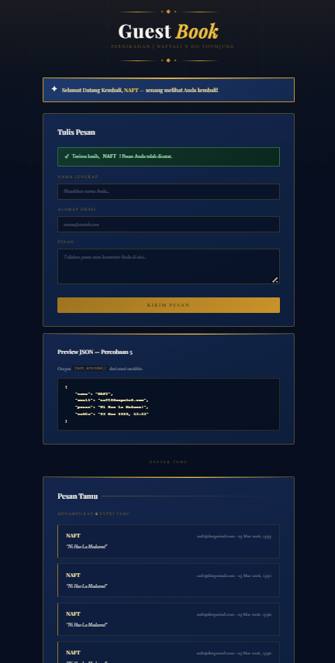

    - Penjelasan
Aplikasi “Simple File-Based Guestbook” ini bekerja sebagai alur lengkap pengolahan data dari pengguna: form menerima input nama, email, dan pesan melalui metode POST, lalu server memvalidasi agar nama tidak kosong dan email sesuai format menggunakan filter_var(), sehingga hanya data yang layak yang diproses lebih lanjut. Data yang lolos validasi kemudian diamankan dengan htmlspecialchars() untuk mencegah injeksi berbahaya, disimpan ke file guestbook.txt menggunakan mekanisme file handling (fopen, fwrite, fclose) sebagai log sederhana, dan nama pengguna disimpan dalam $_SESSION agar sistem bisa mengenali bahwa user baru saja mengisi form dan menampilkan pesan personal “Selamat Datang Kembali”. Setelah itu, aplikasi membaca kembali isi file tersebut (fread) dan menampilkannya di halaman sebagai daftar tamu, sementara penggunaan include pada header dan footer menjaga struktur kode tetap modular dan rapi, sehingga seluruh proses mencerminkan siklus dasar aplikasi web: menerima input, memvalidasi, menyimpan, mengelola state, dan menampilkan kembali data.

DOKUMENTASI
naftali.it.student.pens.ac.id

